**Create a Power Apps Portal**

**Exercise 1: Get started with portals**

1. Go to <https://make.powerapps.com>
2. Select a target environment.
3. On the left menu, select + Create, Select Portal from blank.
4. Provide a name and a unique address (URL)  for the portal.
5. Select the language.
6. Select Create.

**Refer below step by step**

1. Sign in to [Power Apps](https://make.powerapps.com/).
2. Under **Create your app**, select **Blank app**.
3. Select **Create** from the **Blank website** option.

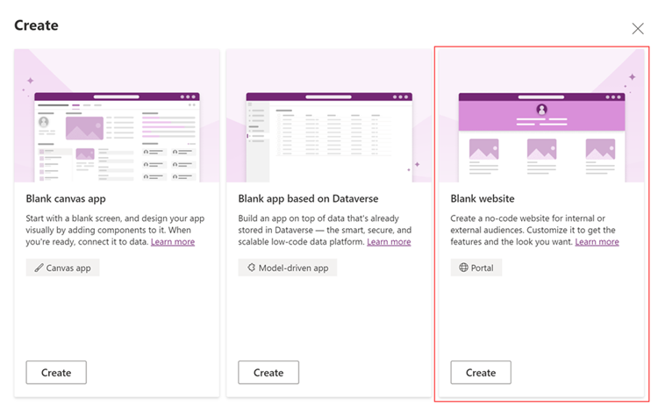

1. In the **Portal from blank** window, enter a name for the portal and address for the website, and select a language from the drop-down list.

1. When you're done, select **Create**.
2. After you select **Create**, the portal will begin provisioning and the provisioning status is displayed through [notifications](https://docs.microsoft.com/en-us/powerapps/maker/portals/create-portal#portal-provisioning-notifications).
3. It will take 14 mins time

1. After the portal is provisioned successfully, the status is updated, and the portal is displayed in the grid

